Masculine Rhyme

🔹 What is Masculine Rhyme (Single Rhyme)
# Source: AI Source: Provided by: [Data Path: Persons Table -> ID Column: 1, Name_En Column: Motasem Essam] -> From: [Chatgpt (GPT-4-turbo)] on [8/2/2025]
⚠️ Masculine rhyme is a type of poetic rhyme, not a true type of homograph, but homographs can appear in masculine rhymes when their pronunciation fits the rhyme pattern.

✅ Definition of Masculine Rhyme
# Source: AI Source: Provided by: [Data Path: Persons Table -> ID Column: 1, Name_En Column: Motasem Essam] -> From: [Chatgpt (GPT-4-turbo)] on [8/2/2025]
Masculine rhyme (also called single rhyme) occurs when the final stressed syllable of two or more words rhymes exactly.
It is the most common rhyme in English poetry.

🧠 Key Features
# Source: AI Source: Provided by: [Data Path: Persons Table -> ID Column: 1, Name_En Column: Motasem Essam] -> From: [Chatgpt (GPT-4-turbo)] on [8/2/2025]
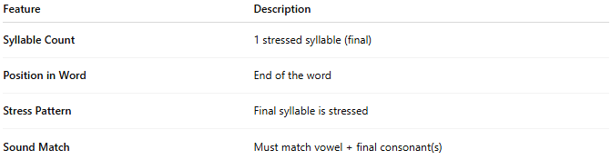
Feature | Description
Syllable Count | 1 stressed syllable (final)
Position in Word | End of the word
Stress Pattern | Final syllable is stressed
Sound Match | Must match vowel + final consonant(s)

📝 Examples of Masculine Rhyme
# Source: AI Source: Provided by: [Data Path: Persons Table -> ID Column: 1, Name_En Column: Motasem Essam] -> From: [Chatgpt (GPT-4-turbo)] on [8/2/2025]
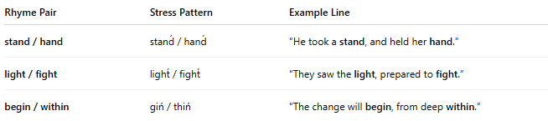
Rhyme Pair | Stress Pattern | Example Line
stand / hand | stand́ / hand́ | “He took a stand, and held her hand.”
light / fight | light́ / fight́ | “They saw the light, prepared to fight.”
begin / within | giń / thiń | “The change will begin, from deep within.”

🧪 Examples with Homographs
# Source: AI Source: Provided by: [Data Path: Persons Table -> ID Column: 1, Name_En Column: Motasem Essam] -> From: [Chatgpt (GPT-4-turbo)] on [8/2/2025]
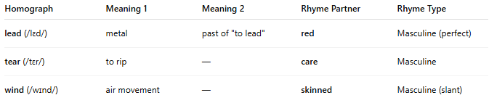
Homograph | Meaning 1 | Meaning 2 | Rhyme Partner | Rhyme Type
lead (/lɛd/) | metal | past of "to lead" | red | Masculine (perfect)
tear (/tɛr/) | to rip | — | care | Masculine
wind (/wɪnd/) | air movement | — | skinned | Masculine (slant)
⚠️ Only valid if pronunciation of the homograph fits the rhyme and syllable stress.

📊 Comparison with Feminine Rhyme
# Source: AI Source: Provided by: [Data Path: Persons Table -> ID Column: 1, Name_En Column: Motasem Essam] -> From: [Chatgpt (GPT-4-turbo)] on [8/2/2025]
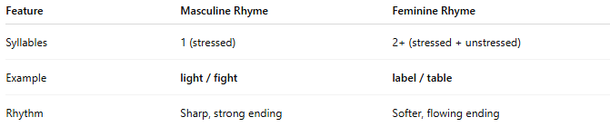
Feature | Masculine Rhyme | Feminine Rhyme
Syllables | 1 (stressed) | 2+ (stressed + unstressed)
Example | light / fight | label / table
Rhythm | Sharp, strong ending | Softer, flowing ending

✅ Summary
# Source: AI Source: Provided by: [Data Path: Persons Table -> ID Column: 1, Name_En Column: Motasem Essam] -> From: [Chatgpt (GPT-4-turbo)] on [8/2/2025]
- Masculine rhyme involves rhyming the final stressed syllables.
- Homographs can be used in masculine rhyme if:
  - Their final syllable is stressed
  - Their pronunciation matches the rhyme partner

